TASK 1
#include <iostream>
using namespace std;

class BankAccount {
int balance;

public:
BankAccount() : balance(0) {}

BankAccount(int bal) : balance(bal) {}

BankAccount(const BankAccount& other) {
balance = other.balance;
}

int getBalance() {
return balance;
}

void deduct (int amount) {
if (amount <= balance) {
balance -= amount;
} else {
cout << "Insufficient funds!" << endl;
}
}
};

int main(){
BankAccount account1;
cout << "Account 1 balance: $" << account1.getBalance() << endl;

BankAccount account2(1000);
cout << "Account 2 balance: $" << account2.getBalance() << endl;

BankAccount account3 = account2;
cout << "Account 3 balance: $" << account3.getBalance() << endl;

account3.deduct(200);
cout << "Account 3 balance after deduction: $" << account3.getBalance() << endl;
cout << "Account 2 balance remains: $" << account2.getBalance() << endl;

return 0;
}

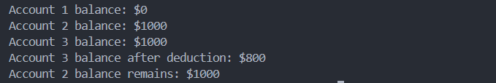

TASK 2
#include <iostream>
#include <string>
using namespace std;

class Exam {
private:
string studentName;
string examDate;
float score;

public:
Exam() : studentName(""), examDate(""), score(0.0f) {}

void setStudentName(const string& name) {
studentName = name;
}

void setExamDate(const string& date) {
examDate = date;
}

void setScore(float s) {
score = s;
}

void display() const {
cout << "Student Name: " << studentName << endl;
cout << "Exam Date: " << examDate << endl;
cout << "Score: " << score << endl;
}
};

int main() {
Exam exam1;
exam1.setStudentName("Ali");
exam1.setExamDate("2024-07-21");
exam1.setScore(95.5f);

cout << "Original Exam:\n";
exam1.display();

Exam exam2 = exam1;
cout << "\nShallow Copied Exam:\n";
exam2.display();

exam2.setStudentName("omer");
exam1.setStudentName("amjad");

cout << "\n--- After Modifying Copied Exam ---\n";
cout << "Original Exam:\n";
exam1.display();
cout << "\nModified Copied Exam:\n";
exam2.display();

return 0;
}

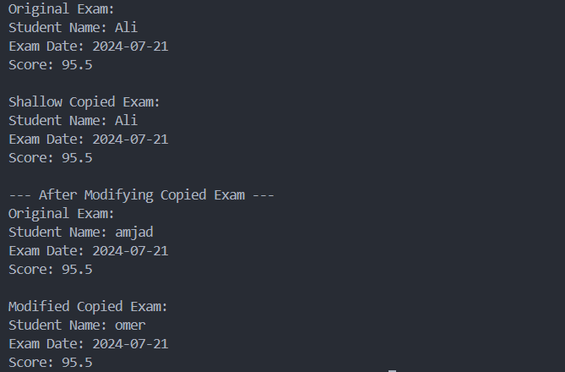

TASK 3
#include <iostream>
using namespace std;

class Box {
private:
int* data;
public:
Box(int value = 0) {
data = new int(value);
}

~Box() {
delete data;
}

Box(const Box& other) {
data = new int(*other.data);
}

Box& operator=(const Box& other) {
if (this != &other) {
delete data;
data = new int(*other.data);
}
return *this;
}

void shallowCopy(const Box& other) {
delete data;
data = other.data;
}

void setValue(int value) {
*data = value;
}

int getValue() const {
return *data;
}
};

int main() {
cout << "Demonstrating Deep Copy:" << endl;
Box b1(10);
Box b2 = b1;
b2.setValue(20);
cout << "b1 value: " << b1.getValue() << endl;
cout << "b2 value: " << b2.getValue() << endl;

Box b3;
b3 = b1;
b3.setValue(30);
cout << "b1 value: " << b1.getValue() << endl;
cout << "b3 value: " << b3.getValue() << endl;

cout << "\nDemonstrating Shallow Copy:" << endl;
Box b4(40);
Box b5;
b5.shallowCopy(b4);
b5.setValue(50);
cout << "b4 value: " << b4.getValue() << endl;
cout << "b5 value: " << b5.getValue() << endl;

return 0;
}

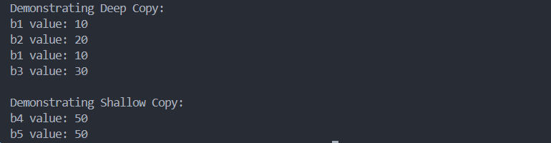

TASK 6
#include <iostream>
using namespace std;

class Shop {
private:
string productName;
int* quantities;
int numBranches;
public:
Shop(const string& name, int branches)
: productName(name), numBranches(branches) {
quantities = new int[numBranches];
for (int i = 0; i < numBranches; ++i)
quantities[i] = 0;
}

~Shop() {
delete[] quantities;
}

Shop(const Shop& other)
: productName(other.productName), numBranches(other.numBranches) {
quantities = new int[numBranches];
for (int i = 0; i < numBranches; ++i)
quantities[i] = other.quantities[i];
}

Shop& operator=(const Shop& other) {
if (this != &other) {
delete[] quantities;
productName = other.productName;
numBranches = other.numBranches;
quantities = new int[numBranches];
for (int i = 0; i < numBranches; ++i)
quantities[i] = other.quantities[i];
}
return *this;
}

void setQuantity(int branch, int quantity) {
if (branch >= 0 && branch < numBranches)
quantities[branch] = quantity;
}

void display() const {
cout << "Product: " << productName << endl;
cout << "Quantities: ";
for (int i = 0; i < numBranches; ++i)
cout << quantities[i] << " ";
cout << endl;
}
};

int main() {
Shop s1("Laptop", 3);
s1.setQuantity(0, 10);
s1.setQuantity(1, 20);
s1.setQuantity(2, 15);
cout << "Original Shop:" << endl;
s1.display();

Shop s2 = s1;
s2.setQuantity(1, 99);
cout << "\nCopied Shop (after modification):" << endl;
s2.display();

Shop s3("Phone", 2);
s3 = s1;
s3.setQuantity(0, 77);
cout << "\nAssigned Shop (after modification):" << endl;
s3.display();

return 0;
}

